ICS-344 - Information Security
Section 02
Ali Kamal Aloryd 202322750
Redha Abdulaziz Alturaik 20232301
http://dvsa-website-test-546079881937-us-east-1.s3-website.us-east-1.amazonaws.com/
us-east-1 (N. Virginia)
Date: 19 April 2026
Over-Privileged Function
Lesson - 7

Goal and Vulnerability Summary
The goal of this lesson is to evaluate whether the Lambda function responsible for sending receipt emails operates with excessive IAM permissions. An over-privileged function occurs when a function is granted permissions beyond what is required for its intended task, increasing the potential attack surface.

Why This Works / Root Cause
Over-privileged vulnerabilities arise when IAM roles use wildcard (*) permissions or broad service access. This violates the principle of least privilege, where each component should only have access to the resources necessary for its function. In this deployment, analysis was conducted to determine whether such misconfiguration exists.

Environment and Setup
The experiment was conducted using the Damn Vulnerable Serverless Application (DVSA) deployed in AWS us-east-1. The architecture includes AWS Lambda, API Gateway, IAM roles, DynamoDB, and CloudWatch. The Lambda function under analysis is DVSA-SEND-RECEIPT-EMAIL.

Reproduction Steps
- Access the AWS Lambda Function
  - Log in to the AWS Management Console.
  - Navigate to the Lambda service.
  - Search for the function: DVSA-SEND-RECEIPT-EMAIL
  - Open the function to view its overview and configuration.
- Inspect the Execution Role
  - Go to the Configuration tab.
  - Select Permissions from the left panel.
  - Identify the Execution Role attached to the function.
  - Click on the role name to open it in IAM.
- Analyze IAM Policies
  - In the IAM Role page, navigate to the Permissions tab.
  - Review all attached policies
  - Check whether any policy contains wildcard (*) permissions or overly broad access
- Open IAM Policy Simulator
- Click Simulate from the IAM Role page.
- Ensure the correct role is selected: serverlessrepo-OWASP-DVSA-SendReceiptFunctionRole
- Test Access to Amazon S3
  - In the simulator: Select Service -> Amazon S3
  - Add actions: GetObject & PutObject
  - Click Run Simulation
  - Observe whether the actions are Allowed or Denied
- Test Access to Amazon DynamoDB
  - Change the service to: Amazon DynamoDB
  - Add actions: Scan & GetItem & PutItem & DeleteItem
  - Click Run Simulation
  - Observe the results
- Enable CloudTrail Logging
  - Navigate to CloudTrail -> Trails
  - Create a new trail: dvsa-policygen-trail
  - Ensure the trail status shows Logging.
- Trigger the Lambda Function
  - Open the DVSA web application.
  - Perform an action that invokes the function: Place a new order
  - This triggers the receipt email Lambda function
- Attempt to Generate Policy from CloudTrail
  - Return to IAM -> Roles -> SendReceiptFunctionRole
  - Scroll to: Generate policy based on CloudTrail events
  - Click Generate policy
  - Observe whether AWS produces a policy or shows: No requests to generate a policy
- Analyze Results
  - Policy Simulator results (Denied access)
  - CloudTrail policy generation outcome
  - Determine whether the role has excessive permissions

Evidence and Proof
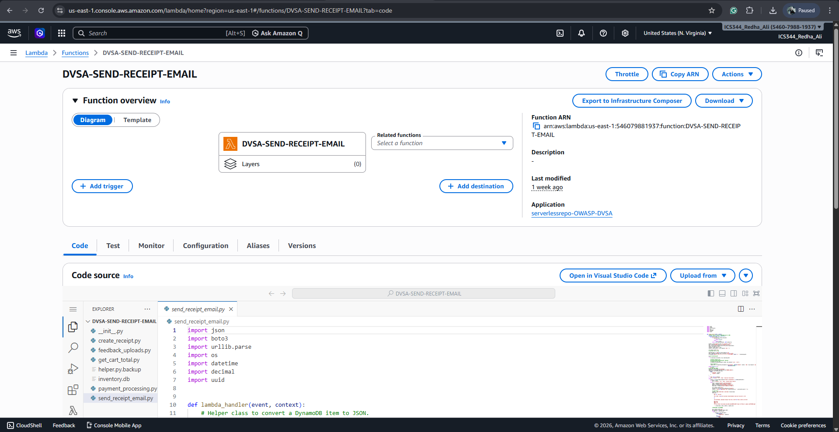
Figure 1. Lambda function SEND-RECEIPT-EMAIL
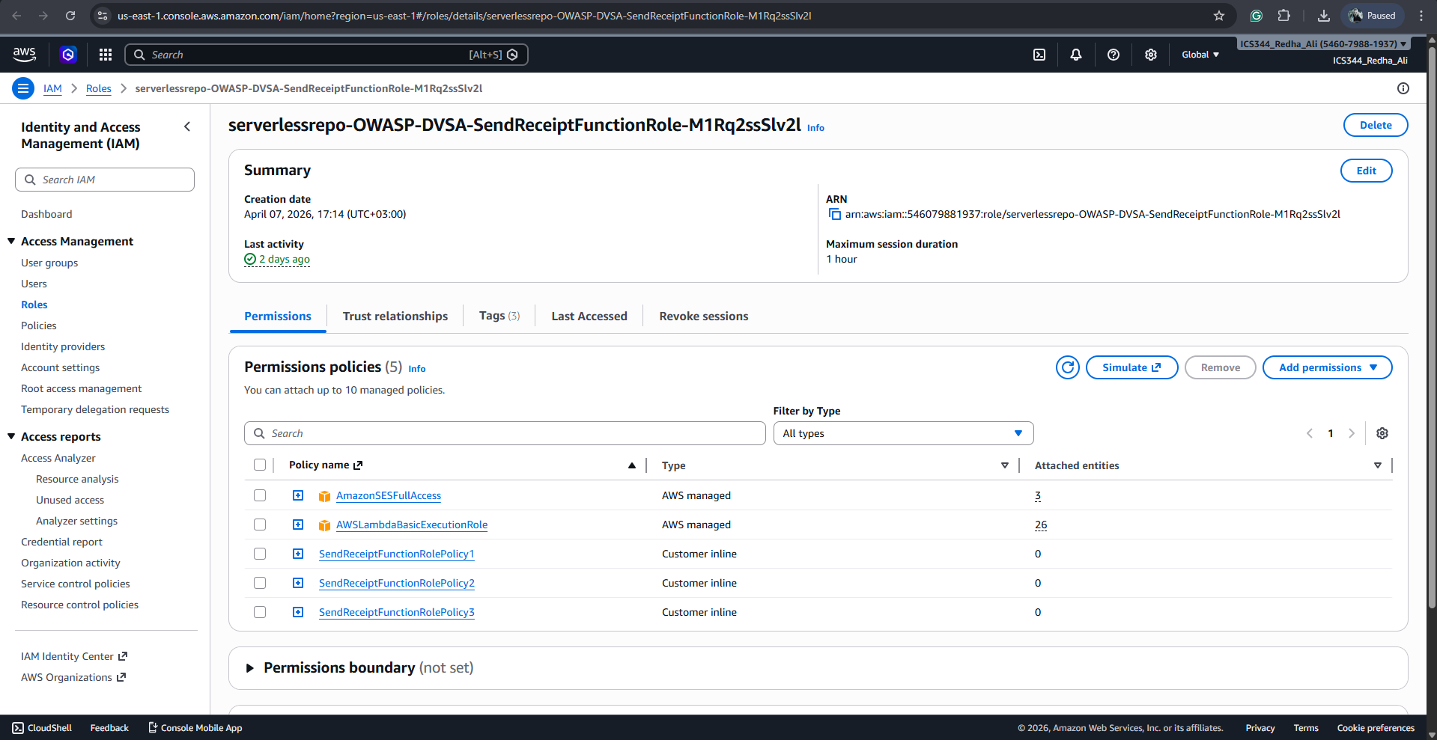
Figure 2. Permissions page
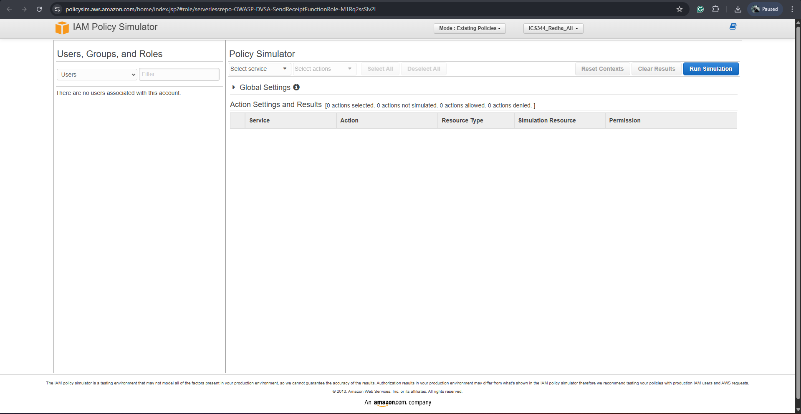
Figure 3. Simulation page
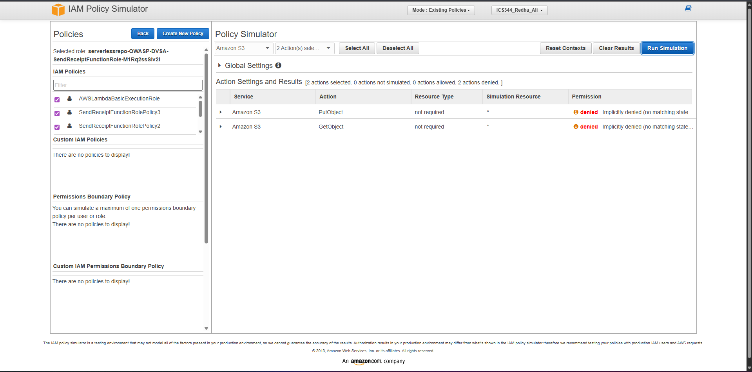
Figure 4. Simulation on Amazon S3
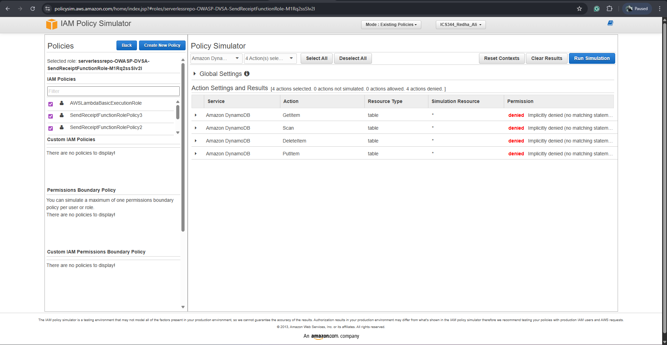
Figure 5. Simulation on Amazon DynamoDB
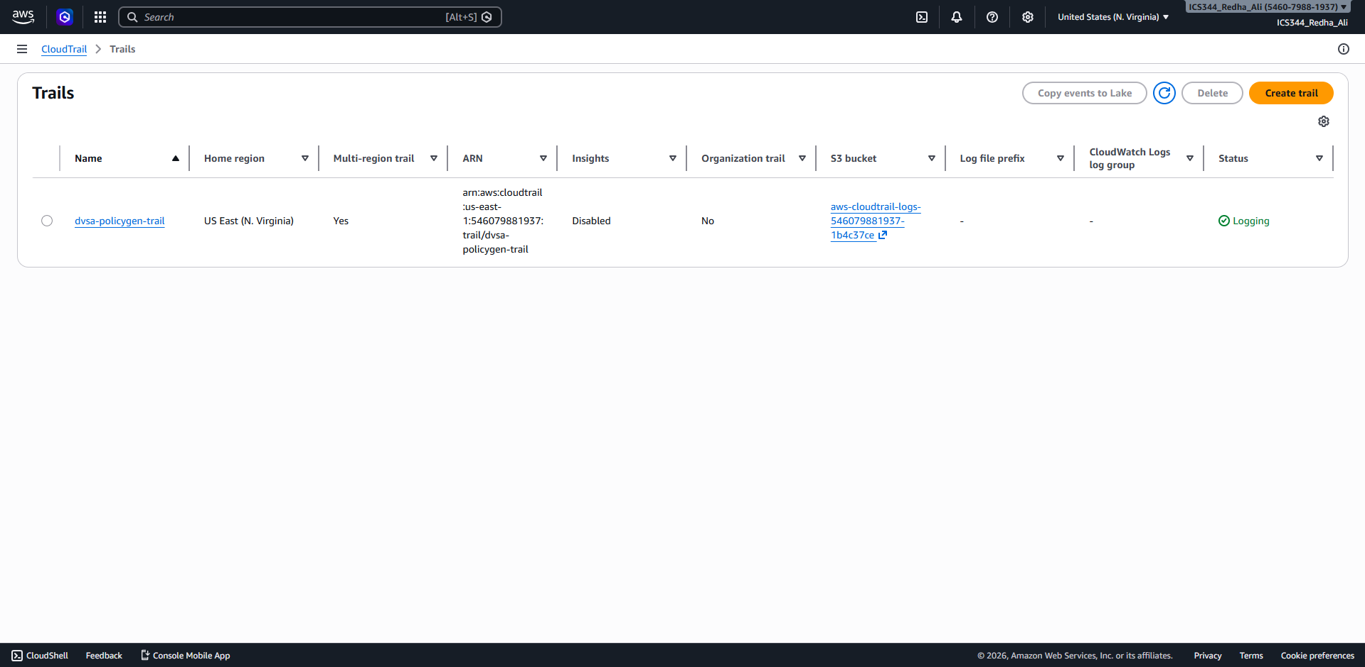
Figure 6. Trail created
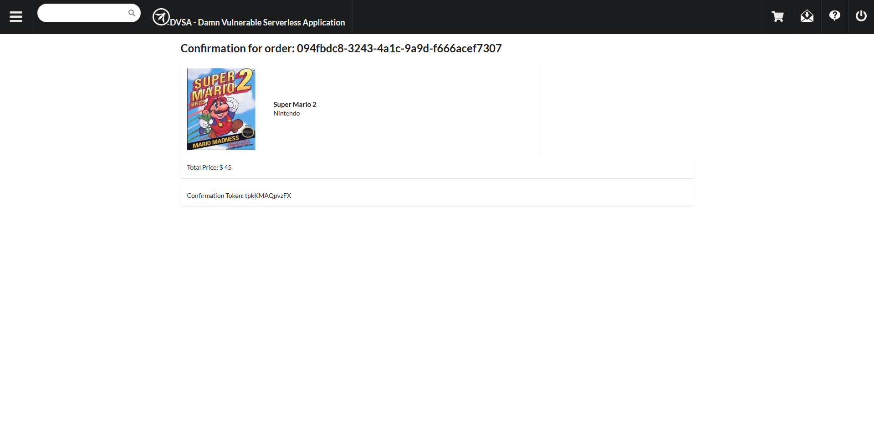
Figure 7. Order placed

Fix Strategy / Probable Mitigation
To mitigate over-privileged vulnerabilities, IAM roles should follow the principle of least privilege. Permissions should be restricted to specific resources rather than using wildcard (*). Additionally, unnecessary managed policies such as full-access roles should be removed or replaced with scoped policies.

Code / Config Changes
Although no over-privileged behavior was observed in this deployment, a secure configuration must still follow the principle of least privilege. The following illustrates how an over-privileged IAM policy should be corrected.
Vulnerable Configuration
An over-privileged role may grant excessive permissions using wildcards:
{
"Effect": "Allow",
"Action": ["s3:GetObject"],
"Resource": "arn:aws:s3:::dvsa-receipts-bucket/*"
}
This configuration allows unrestricted access to all S3 buckets and operations, which significantly increases the attack surface.
To enforce least privilege, permissions should be limited to only the required actions and specific resources:
{
"Effect": "Allow",
"Action": ["s3:GetObject"],
"Resource": "arn:aws:s3:::dvsa-receipts-bucket/*"
}
Similarly, DynamoDB access should be restricted:
{
"Effect": "Allow",
"Action": ["dynamodb:GetItem"],
"Resource": "arn:aws:dynamodb:us-east-1:ACCOUNT_ID:table/DVSA-ORDERS"
}

Verification After Fix
Verification was performed using the IAM Policy Simulator. Unauthorized actions on S3 and DynamoDB remained denied, confirming that the system enforces restricted access and follows least privilege principles.

Structured Operation and Security Analysis

Table 1: Structured analysis summary — Table A
Vulnerability | Intended Rule(s) | Artifacts Used to Infer Rule | Normal Behavior Evi dence | Exploit Behavior Evi dence
Over-Privileged Function | Lambda should access only required resources | IAM policies, simulator | Limited access | No exploit possible (Denied)

Table 2: Structured analysis summary — Table B:
Vulnerability | Why This Is a Deviation | Deviation Class | Fix Applied  (where) | Post-Fix Verification
Over-Privileged Function | No deviation observed | N/A | Not required | Simulator shows denied

Takeaway / Lessons Learned
This lesson demonstrates the importance of validating IAM permissions in serverless applications. Even when vulnerabilities are expected, modern deployments may enforce secure configurations. Tools such as IAM Policy Simulator and CloudTrail are essential for verifying access control and ensuring adherence to least privilege.

